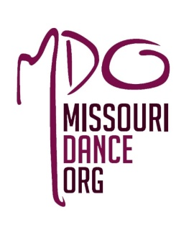
Presenter Application 2020
Connecting Missouri Dance
Saturday, June 27, 2020
Washington University
St. Louis, MO
PROPOSAL APPLICATION DEADLINE APRIL 15, 2020 Notification of acceptance will go out by May 1, 2020. Register by May 15, 2020 to confirm acceptance of our presenting opportunity.
E-mail completed form to Dr. Alice Bloch abloch45@gmail.com
CONTACT INFORMATION
Organization Affiliation or Independent: _________________________________________________________
Address:___________________________________________________________________________________
Role: _____________________________________________________________________________________
Website:___________________________________________________________________________________
E-mail: ____________________________________________________________________________________
Phone number: _____________________________________________________________________________
PRESENTER INFORMATION
Proposal Type: Master Class_______; Workshop_____; Paper:_______; Panel_______; Lecture/demonstration:__________
Durations-three options: 1) 1:20_____ 2) :50_____ 3) :20 (ie. Thesis presentation)______
Description (250 words):

Biography (250 words):

